Project Design Phase-II
Data Flow Diagram & User Stories

Date | 20 Febuaury 2025
Team ID | LTVIP2026TMIDS79198
Project Name | Resolve Now- Your Platform for Your Platform
Maximum Marks | 4 Marks

Data Flow Diagrams:
A Data Flow Diagram (DFD) is a graphical representation of how data moves through a system. It shows how users interact with the complaint system, how complaints are processed, and how administrators manage and resolve them
.Example: (Simplified)
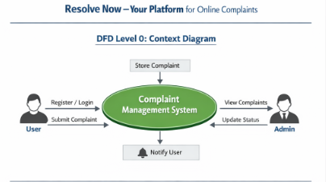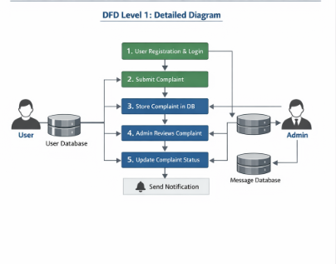
User Stories
Use the below template to list all the user stories for the product.

Customer (Web User)
User Type | Functional Requirement (Epic) | User Story Number | User Story / Task | Acceptance Criteria | Priority | Release
User | Registration | USN-1 | As a user, I can register by entering name, email, password and confirm password | User account created & redirected to dashboard | High | Sprint-1
User | Email Verification | USN-2 | As a user, I receive confirmation email after registration | Email received & verified successfully | High | Sprint-1
User | Login | USN-3 | As a user, I can login using email & password | User redirected to dashboard | High | Sprint-1
User | Submit Complaint | USN-4 | As a user, I can submit a complaint with title, description & category | Complaint stored in database | High | Sprint-1
User | Track Complaint | USN-5 | As a user, I can track complaint status | Status visible (Pending / In Progress / Resolved) | High | Sprint-2
User | Chat Support | USN-6 | As a user, I can chat with support executive | Messages saved & visible in chat window | Medium | Sprint-2
User | Provide Feedback | USN-7 | As a user, I can provide feedback after complaint resolution | Feedback stored successfully | Medium | Sprint-3

Support Executive
User Type | Functional Requirement (Epic) | User Story Number | User Story / Task | Acceptance Criteria | Priority | Release
Support Executive | View Assigned Complaints | USN-8 | As a support executive, I can view assigned complaints | Assigned complaints list displayed | High | Sprint-2
Support Executive | Update Status | USN-9 | As a support executive, I can update complaint status | Status updated successfully | High | Sprint-2
Support Executive | Respond to User | USN-10 | As a support executive, I can reply to user queries | Message delivered to user | Medium | Sprint-2

Administrator
User Type | Functional Requirement (Epic) | User Story Number | User Story / Task | Acceptance Criteria | Priority | Release
Admin | Manage Users | USN-11 | As an admin, I can view and manage users | User list displayed & editable | High | Sprint-1
Admin | Assign Complaints | USN-12 | As an admin, I can assign complaints to support executives | Complaint assigned successfully | High | Sprint-2
Admin | View Reports | USN-13 | As an admin, I can view complaint analytics & reports | Reports generated correctly | Medium | Sprint-3

